COVID-19 in San Antonio and Bexar County

Uma Yeruva

Samantha Brown

Ahmed Dahham

Julia Lira

We were influenced by current events and inspired our COVID-19 research was the amount of data that was available to our disposal. We were able to find a vast array of data that at the global level, all the way down to local hospitals. As we began our analysis of the data, we soon found ourselves overwhelmed with the sheer amount of data we collected and we needed a way to narrow down the analysis in a way that fit into our time limitations, but also felt relevant and complete. Since our whole team is from San Antonio, we decided to focus on our city’s response to the pandemic and how we have done compared to the rest of the state when it came to terms to infection and vaccination rates.

We then encountered our next issue, the lack of consistency when it came to reporting infection as some counties collected daily, and some weekly, rates. Having to locate standardized data was troublesome, but we eventually were able to locate sources on the Department of Health and Human Services and used what we found and standardized the data to monthly data by taking the average of infection rate and vaccination rate per month of 2021, so we could compare it to the San Antonio/Bexar county data. This was when we were able to finally ask of our data our research question – How did San Antonio vaccination push compare to the rest of the state of Texas when broken down by county? We asked secondary question out of curiosity, were certain demographics equally vaccinated when it came to population? Were there a certain demographic, such as race or gender more likely to be vaccinated?

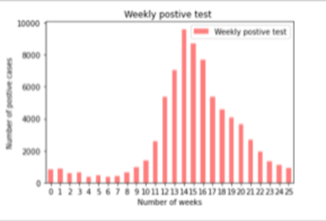To answer our first question, we pulled the San Antonio data and focused on infection rates and vaccination rates to determine if there was a change to infection rates in the year 2021 since the vaccines were made widely available in the springtime. We also looked at testing rates to help us visualize the number of confirmed cases to compare with the vaccination rates. This allowed us to conclude that due to the vaccine, the rate of infection is slowing down, as were the number of deaths. We hope this trend continues as the population becomes more vaccinated.

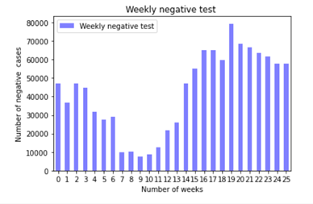To answer our second question, we were able to visualize that the males of San Antonio were at higher rates receiving their first dose, while the females were more fully vaccinated. For race, due to San Antonio population, Hispanics were more vaccinated than other races, with white and other ethnicities following by the same amount combined. This was different than the state’s rate, where the Asian population was the most vaccinated out of the ethnicities, even though they are one of the smaller populations of Texas.